Abbey Road Primary School

**Advert:**

**Teaching Assistant**

**Required for February 2025 until 30th July 2025**

Abbey Road Primary School is seeking to appoint a Teaching Assistant to join our hardworking and dedicated staff team. The role is fixed term, for the rest of this academic year.

**32.5 hours per week** – Monday-Friday

£23,656-£24,404 full time, all year round equivalent (NJC Grade 2 – pay award pending). Actual term-time only, part time salary is £20,689-£21,360, based on 45.6 weeks pay per year (39 working weeks plus annual leave). This will be prorated for the duration of the contract.

We are looking for a candidate who:

* Enjoys being with children and puts children’s well-being at the heart of all they do.
* Has experience of working with children with SEND and has high aspirations for their achievement.
* Believes in the capacity of all young people to learn and grow, despite the various challenges they face.
* Has a positive and enthusiastic attitude.
* Is able to show initiative, creativity and resilience.
* Is a strong team player, willing to go the extra mile to make school a great experience for our pupils.
* Demonstrates a good standard of written and spoken English.

The role will involve working alongside the class teacher, other teaching assistants and the school SENCO to support children on a 1:1 basis, helping to equip them with the skills and confidence needed to thrive in an inclusive, supportive learning environment.

Abbey Road is a friendly, caring primary school and our children really enjoy coming to school. Successful candidates will have the opportunity to work with the support of a committed and skilled team who provide a caring and engaging learning experience for our children.

We are committed to safeguarding and promoting the welfare of children and young people and expect all staff and volunteers to share this commitment. All posts are therefore subject to an enhanced DBS disclosure and references confirming candidates’ suitability to work with children.

See all of our Trust vacancies and apply through our dedicated recruitment webpage here: <https://equalstrust.face-ed.co.uk/vacancies>

Deadline for applications to be received by: 12 noon on Tuesday 28th January 2025.

If you have any further questions or would like to discuss any aspect of this position further, please contact our headteacher, Ly Toom – head@abbeyroadprimary.co.uk.

Interviews are scheduled to take place on 30th and 31st January 2025.

Abbey Road Primary School is situated in West Bridgford, within the borough of Rushcliffe. Currently, we have 430 children on roll, divided between 14 classes.

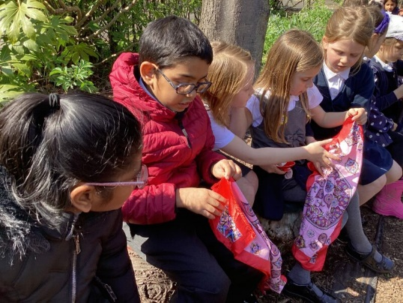We are a happy and inclusive school and we work hard to make sure our children feel valued, safe, secure and aware of the needs of others. At the heart of this lies the strength of relationships between both pupils and staff. A warm, supportive atmosphere permeates our school and this is evident in the outstanding behaviour of our children. All are encouraged to ‘**take care and be proud’** – of each other as well as themselves; of the work they do and the school environment - and our dedicated staff team make the time to get the best from each child, ensuring individuality is nourished and nurtured. We know that children who join us, quickly feel at home and enjoy learning. We devote a great deal of time, effort and energy to planning for the achievement of our children, helping them to discover new talents and to be successful in their own right, regardless of age, ability or personal circumstances. We very much value our excellent partnership with parents and carers and welcome their support and involvement. We know that by working together, we can enable every child to be the best that they can be.

**OUR ‘TAKE CARE’ CODE**

At Abbey Road, we take care of:

* **ourselves** *– we are resilient*
* **each other** *– we are kind*
* **our work** *– we are ambitious*
* 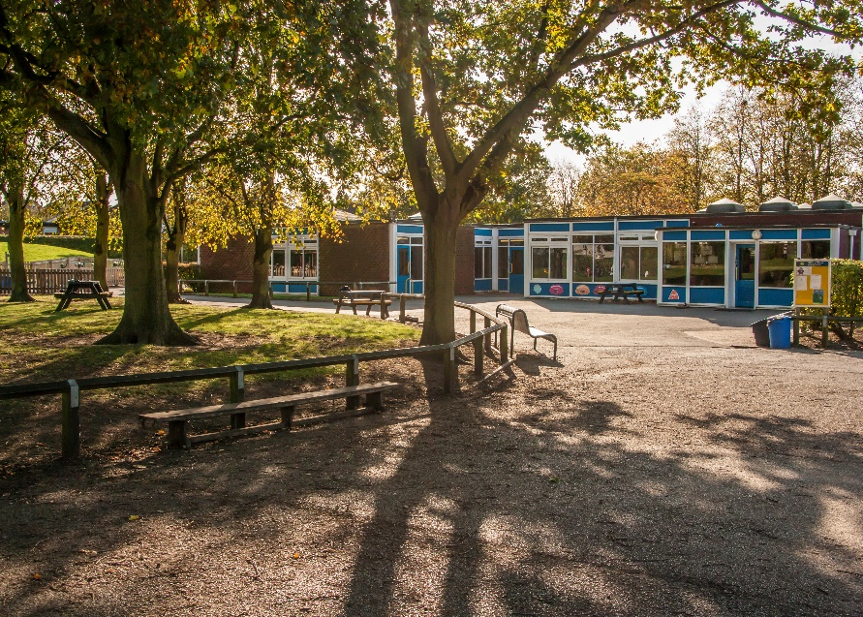**our world** *– we are respectful*

Our site is an extensive green-field one and our pupils have access to large grounds. The school is made up of two main buildings and we currently have a double classroom mobile unit, which houses our Year 4 classes. We also have a bungalow on site that offers further rooms for meetings, music tuition, intervention work and enrichment activities. In addition, our ‘NEST’ houses our ‘Nurture and Emotional Support Team’ who work with individuals and small groups across school.

Abbey Road is a member of the Equals Trust, which consists of twelve local primary schools - <http://www.equalstrust.org/>. The trust has a strong collaborative approach to staff development and school improvement, although member schools continue to maintain their ethos and unique identities.

This is a great place to start your career as a Teaching Assistant, if you are relatively new to the role or one which will further contribute to your professional development if you already have some experience.

As with any school, the best way of appreciating the above words is to come and visit us so you are able to see the school and experience its atmosphere for yourself. It is equally important that we are the right school for you as it is that you are the right candidate for us.

Please email [head@abbeyroadprimary.co.uk](mailto:head@abbeyroadprimary.co.uk) or call 0115 974 8055 to arrange a visit, or if you have any questions about the posts.

If you aren’t able to visit prior to applying, our website: [www.abbeyroadprimary.co.uk](http://www.abbeyroadprimary.co.uk) and our twitter feed: [twitter.com/AbbeyRoadSchool](https://twitter.com/AbbeyRoadSchool) will give you a flavour of Abbey Road life and a chance to see some of the activities that take place here.

Best of luck!

Ly Toom

Headteacher

|  |  |  |  |
| --- | --- | --- | --- |
| **Job Description** | | |  |
| ***Title:***  **TEACHING ASSISTANT - PRIMARY**  **Grade 2 (points 2 – 4)** | ***School:***  ***Abbey Road Primary School*** | **Profile:**  **Learning Support 2a PRI** |
| ***Job Purpose***  To work under the direct instruction of teaching/senior staff, to support access to learning for pupils and provide general support to the teacher in the management of pupils and the classroom. Work may be carried out in the classroom or outside the main teaching area, alongside a teacher/senior member of staff. | | |
| ***Key Responsibilities***   1. Attending to the pupils’ personal needs and implement related personal programmes, including social, health, physical, hygiene, first aid and welfare matters, including the use of specialist equipment where necessary 2. Providing support for students with emotional, social and behavioural problems 3. Providing practical assistance in relation to other identified physical needs 4. Supervising and supporting pupils ensuring their safety and access to learning and play 5. Working to establish a supportive relationship with the children and parents/carers and families concerned 6. Promoting the inclusion and acceptance of all pupils 7. Encouraging pupils to interact with others and engage in activities led by the teacher 8. Encouraging pupils to act independently as appropriate 9. Preparing classroom as directed for lessons and clear afterwards and assist with the display of pupils’ work 10. Being aware of pupil barriers to learning/progress/achievements and report to the teacher as agreed 11. Supporting the teacher in managing pupil behaviour, reporting difficulties as appropriate 12. Gathering/reporting information from/to parents/carers as directed 13. Working with and acting upon guidance provided by teachers and other professionals/outside agencies 14. Providing support for such tasks as clerical, administrative, photocopying, display, collection and recording of money 15. Supporting pupils in their learning in all areas of the curriculum 16. Supporting pupils in respect of local and national learning strategies e.g. literacy, numeracy, as directed by the teacher 17. Supporting pupils and teacher during PE and other practical activities 18. Preparing and maintaining equipment/resources as directed by the teacher and assist pupils in their use 19. Assisting with the supervision of pupils at break times 20. Accompanying teaching staff and pupils on visits, trips and out of school activities as required   **General Responsibilities**   1. Be aware of and comply with school policy and procedures particularly in respect of Child Protection and Health and Safety 2. Be aware of and support difference and ensure all pupils have equal access to opportunities to learn and develop 3. Contribute to the overall ethos/work/aims of the school 4. Ensure the safe organisation of learning activities and the physical teaching space and resources for which they have responsibility 5. Appreciate and support the role of other professionals 6. Attend relevant meetings as required 7. Participate in training and other learning activities and performance development as required 8. Be aware of confidential issues linked to home/pupil/teacher/school work and to keep confidences as appropriate 9. Any other curriculum duties which may reasonably be regarded as within the nature of the duties and responsibilities/grade of the post as defined, subject to the proviso that normally any changes of a permanent nature shall be incorporated into the job description in specific terms, following consultation with the Recognised Trade Unions 10. To promote and safeguard the welfare of children and young persons for whom you are responsible and with whom you come into contact with during the course of your duties and responsibilities. Your conduct must at all times be in accordance with the school’s policies and procedures 11. To report any causes for concern relating to the welfare and safety of children to the designated person, and the head teacher, or if unavailable the designated safeguarding governor or a member of the senior leadership team 12. To attend safeguarding training as required by the school and maintain your knowledge and understanding of your responsibility for safeguarding children in this school | | | |

Note: It is expected that duties will be undertaken within contracted hours unless by agreement

**Person Specification**

**Job Title: Grade 2 Teaching Assistant**

|  |  |  |
| --- | --- | --- |
|  | **Essential** | **Desirable** |
| **Qualifications** | |  | | --- | | The Teaching Assistant should have:   * Good literacy and numeracy skills gained from general education to GCSE ‘O’ level/NVQ level 2 standard or equivalent or prior relevant experience or skills. * The ability to communicate clearly and demonstrate a good standard of written and spoken English. | | In addition, the Teaching Assistant might have:   * GCSE English & Maths (Grade C or above) or the equivalent * A relevant qualification in Childcare and/or Education |
| **Experience** | The Teaching Assistant should have:   * Experience of working with young children with Special Educational Needs – for example: speech, language and communication difficulties; ASC; cognition & learning needs; sensory and/or physical needs, social, emotional and mental health needs |  |
| **Knowledge and Understanding** | Knowledge & understanding of:   |  | | --- | | * The National Curriculum/Early Years Foundation Stage Framework * The needs of young children * Positive behaviour management strategies * Equality of Opportunity for all * Knowledge of procedures to provide personal care and support to children and young people. * Safeguarding | | Knowledge and understanding of:   * Tools for measuring progress of children with SEN – for example: P Levels |
| **Skills**  **Personal Characteristics** | The Teaching Assistant will be able to:   * Support children on an individual basis - within small groups and whole class activities * Record any observations and report as required. * Communicate tasks effectively and foster independence; * Adhere to defined behaviour management policies * Work with guidance, but under limited supervision * Liaise and communicate effectively with others * Demonstrate good organisational skills * Create and maintain basic teaching resources * Take part in all relevant training and show a commitment to one’s own professional development * Demonstrate the ability to learn and adapt from past experience.   The Teaching Assistant will be able to demonstrate:   * Calmness * Confidentiality * Resilience * Enthusiasm * Flexibility * Initiative | In addition, the Teaching Assistant might also be able to:   * Monitor, record and make basic assessments about individual progress * Suggest alternative strategies to support a child to make progress |