Abbey Road Primary School

**Advert:**

**Personal Care Assistant**

**Required for September 2025**

Abbey Road Primary School is seeking to appoint a Personal Care Assistant to join our hardworking and dedicated staff team.

The role is fixed term, for one year – 1st September 2025 - 30th July 2026.

**Salary:** £23,656

**Closing Date:** 26/06/2025 00:00 **Interview Date:** 03/07/2025 **Start Date:** 1st September 2025

**Additional Information**

**Contract Type:**Fixed Term (30/07/2026) **Contract Term:**TTO - Term time only

**Hours per Week:**32.50 - Monday-Friday (08:30-16:00) **Weeks per Year:**45.600

**Pay Grade:**Support Staff – grade 1

We are looking for a candidate who:

* Enjoys being with children and puts children’s well-being at the heart of all they do.
* Has experience of working with children with SEND and has high aspirations for their achievement.
* Believes in the capacity of all young people to learn and grow, despite the various challenges they face.
* Has a positive and enthusiastic attitude.
* Is able to show initiative, creativity and resilience.
* Is a strong team player, willing to go the extra mile to make school a great experience for our pupils.
* Demonstrates a good standard of written and spoken English.

The role will involve working alongside class teachers, other teaching assistants and the school SENCO to support a year 1 child on a 1:1 basis, helping to equip them with the skills and confidence needed to thrive in an inclusive, supportive learning environment.

The successful candidate will have the opportunity to work with the support of a committed and skilled team who provide a caring and engaging learning experience for our children.

If you have any further questions or would like to discuss any aspect of this position further, please contact our headteacher, Ly Toom – head@abbeyroadprimary.co.uk.

Interviews are scheduled to take place on Thursday 3rd July 2025.

Abbey Road Primary School is situated in West Bridgford, within the borough of Rushcliffe. Currently, we have 434 children on roll, divided between 14 classes.

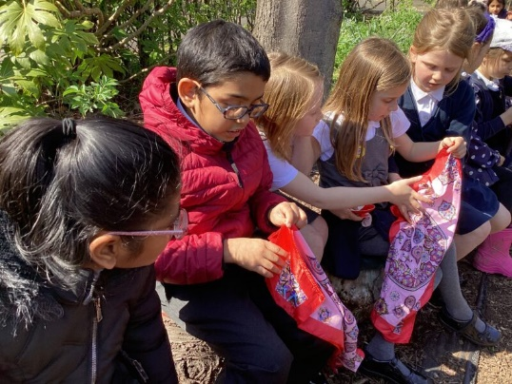We are a happy and inclusive school and we work hard to make sure our children feel valued, safe, secure and aware of the needs of others. At the heart of this lies the strength of relationships between both pupils and staff. A warm, supportive atmosphere permeates our school and this is evident in the outstanding behaviour of our children. All are encouraged to ‘**take care and be proud’** – of each other as well as themselves; of the work they do and the school environment - and our dedicated staff team make the time to get the best from each child, ensuring individuality is nourished and nurtured. We know that children who join us, quickly feel at home and enjoy learning. We devote a great deal of time, effort and energy to planning for the achievement of our children, helping them to discover new talents and to be successful in their own right, regardless of age, ability or personal circumstances. We very much value our excellent partnership with parents and carers and welcome their support and involvement. We know that by working together, we can enable every child to be the best that they can be.

**OUR ‘TAKE CARE’ CODE**

At Abbey Road, we take care of:

* **ourselves** *– we are resilient*
* **each other** *– we are kind*
* **our work** *– we are ambitious*
* 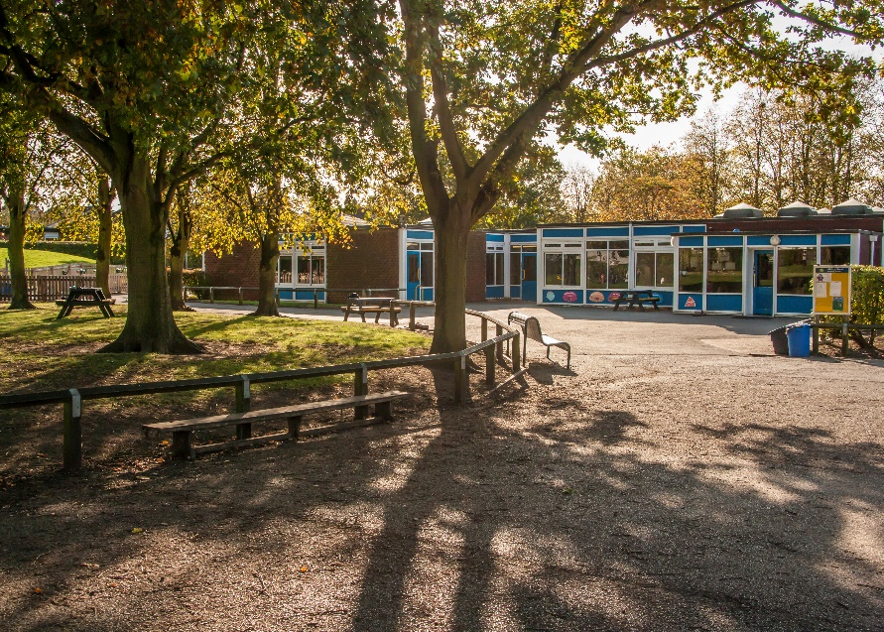**our world** *– we are respectful*

Our site is an extensive green-field one and our pupils have access to large grounds. The school is made up of two main buildings and we currently have a double classroom mobile unit, which houses our Year 4 classes. We also have a bungalow on site that offers further rooms for meetings, music tuition, intervention work and enrichment activities. In addition, our ‘NEST’ houses our ‘Nurture and Emotional Support Team’ who work with individuals and small groups across school.

Abbey Road is a member of the Equals Trust, which consists of twelve local primary schools - <http://www.equalstrust.org/>. The trust has a strong collaborative approach to staff development and school improvement, although member schools continue to maintain their ethos and unique identities.

This is a great place to start your career as a Teaching Assistant, if you are relatively new to the role or one which will further contribute to your professional development if you already have some experience.

As with any school, the best way of appreciating the above words is to come and visit us so you are able to see the school and experience its atmosphere for yourself. It is equally important that we are the right school for you as it is that you are the right candidate for us.

Please email [head@abbeyroadprimary.co.uk](mailto:head@abbeyroadprimary.co.uk) or call 0115 974 8055 to arrange a visit, or if you have any questions about the posts.

If you aren’t able to visit prior to applying, our website: [www.abbeyroadprimary.co.uk](http://www.abbeyroadprimary.co.uk) will give you a flavour of Abbey Road life and a chance to see some of the activities that take place here.

Best of luck!

Ly Toom

Headteacher

|  |  |  |
| --- | --- | --- |
| **Job Description** | |  |
| ***Title:***  **PERSONAL CARE ASSISTANT - PRIMARY**  **Grade 1 (point 2)** | ***School:***  ***Abbey Road Primary School*** |
| **General Conditions of Post**  Personal Care Assistants are appointed to work with children over the whole age range as part of a team under the general direction of the Head Teacher who will be responsible for the overall policy and educational programme and for matters of control and discipline within the appropriate Articles of Government. | |
| **General Description**  The Personal Care Assistant will be a member of the support staff under the general supervision of the class teacher and SENDCo. The general duties will be to assist pupils with their day-to-day personal care needs and to work alongside other professional staff to further pupils’ personal independence skills.  1. Working as part of a team in the development of personal care programmes for pupils.  2. Assisting pupils in implementing their own personal care programmes during the school day, specifically in relation to practical support for:  personal hygiene  toileting and continence training  eating and drinking  3. Provide practical assistance in relation to other identified physical needs e.g. transportation, manual handling, dressing, grooming, meal times.  4. Keeping records related to personal care in conjunction with the appropriate teacher/teaching assistant.  5. Maintenance and cleaning of personal care equipment and materials, clothing etc. Maintenance of toiletry supplies.  6. Provide personal assistance to identified pupil/pupils in physical/practical activities e.g. physical education, cookery, school visits, therapeutic treatments organised by the school etc.  7. Participate in staff meetings, in-service training and courses.  8. Work in co-operation with other keyworkers involved in supporting the pupils’ educational and health care needs under the guidance of the class teacher, SENCO, teaching assistant.  9. Work within the framework of the school’s agreed polices and procedures.  10. Any other duties which may reasonably be regarded as within the nature of the duties and responsibilities/grade of the post as defined, subject to the proviso that normally any changes of permanent nature shall be incorporated into the job description in specific terms.  **Hours of work:**  The working week will be 32.5 hours | | |

Note: It is expected that duties will be undertaken within contracted hours unless by agreement

**Person Specification**

**Job Title: Grade 1 Personal Care Assistant**

|  |  |
| --- | --- |
| **Qualifications** | * No formal qualifications required. * Willingness to undertake training in personal care, manual handling, safeguarding, and health and safety procedures. * Basic literacy and numeracy skills. |
| **Experience** | * Experience of working with children or young people (desirable). * Experience of providing personal care in a professional or personal capacity (desirable). * Experience of working as part of a team (essential). * Experience using or supporting the use of mobility equipment (desirable but not essential – training will be provided). |
| **Knowledge and Understanding** | * Awareness of the importance of maintaining dignity, respect, and confidentiality when supporting personal care needs. * Understanding of the need to follow agreed procedures and individual care plans. * Awareness of manual handling safety and the need for safe practice in physical support (training will be provided). * Basic understanding of safeguarding and child protection principles. * Awareness of health and hygiene standards, particularly in relation to toileting, eating, and personal hygiene (desirable). |
| **Skills** | * Ability to communicate effectively with children and adults. * Ability to follow instructions and work under supervision. * Ability to maintain accurate records related to care needs. * Able to carry out physical tasks such as lifting and moving children (with training and appropriate equipment). * Practical skills related to personal care routines (eg: toileting, feeding). * Good organisational skills. |
| **Personal Characteristics** | * Patient, caring and empathetic. * Respectful of children's dignity and rights. * Reliable and punctual. * Willing to learn and develop professionally. * Able to remain calm and positive in challenging situations. * Flexible and adaptable to the changing needs of the child and school environment. * Committed to promoting inclusion and supporting children with additional needs to develop independence. |